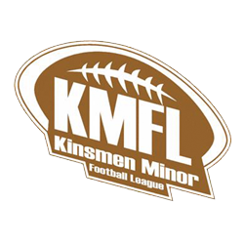
Update to KMFL Constitution and Governance Documents

The Kinsmen Minor Football League (KMFL) recently completed updates to its constitution, bylaws, policies, and code of conduct. These updates were made to ensure that the league complies with the requirements of the Ontario Not-for-Profit Corporations Act (ONCA), which governs how not-for-profit organizations operate in Ontario.
ONCA came into effect in October 2021 and provided existing organizations with a three-year transition period to review and update their governing documents. That transition period ended in October 2024.
In preparation for this requirement, KMFL conducted a review of our governance documents in consultation with legal counsel to ensure that our constitution, bylaws, policies, and code of conduct align with the requirements of ONCA and reflect current best practices for nonprofit organizations.
These updates were made in the best interests of the organization to help ensure strong governance, transparency, and the long-term stability of the league.
KMFL remains committed to providing a safe, positive, and well-organized football experience for all athletes, families, coaches, and volunteers in our community.
If you would like to learn more about the legislation that governs Ontario not-for-profit organizations, please visit the Government of Ontario information page for the Ontario Not-for-Profit Corporations Act:
https://www.ontario.ca/page/not-profit-corporations-act-2010

