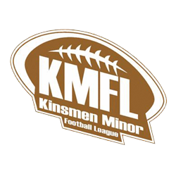
Kinsmen Minor Football League

Refund Policy

1. Before the Season Begins
A full refund of the registration fee, less any administrative or processing costs, will be issued if an athlete withdraws before the official start of the season.

2. After the Season Has Begun
Once the season has started, if an athlete chooses not to play for any reason or requests a refund, only 50% of the registration fee paid will be refunded.
This policy applies regardless of the reason for withdrawal, including personal, medical, or scheduling conflicts.

3. Exceptions
KMFL reserves the right to consider exceptional circumstances (e.g., league cancellation, insufficient team enrollment) at the discretion of the Executive Board.
Any exceptions will be determined on a case-by-case basis.

4. Refund Process
Refund requests must be submitted in writing to the KMFL Executive.
Approved refunds will be processed within 30 days.
No refunds will be issued until all league-issued equipment has been returned in good condition.

Acknowledgment:
I, the undersigned, acknowledge that I have read, understood, and agree to the Kinsmen Minor Football League Refund Policy as outlined above.
Parent/Guardian Name: _______________________________
Athlete Name: ______________________________________
Date: _____________________________________________
Signature: _________________________________________

