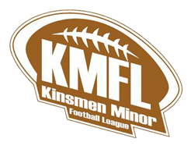 | Kinsmen Minor Football League (KMFL)  910 High Street Unit #3  Peterborough, Ontario K9J 5R2

August 7, 2025

To Whom It May Concern:
This letter will confirm that is an unpaid volunteer/coach/manager/trainer with the Kinsmen Minor Football League which is registered with Football Ontario.
The mentioned individual is involved in youth football and will be have authority over and be entrusted with children under the age of 18 and therefor requires a vulnerable sector check.
Should you have any additional questions or concerns, please don’t hesitate to reach out to me at vicepresident@kmfl.ca .

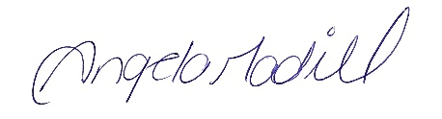

Annge Madill
705-868-4804
vicepresident@kmfl.ca
President KMFL

