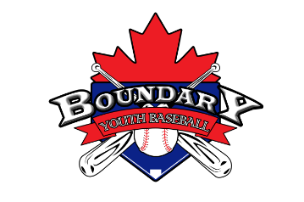

Boundary Youth Baseball
Players Codes of Conduct Policy

The Boundary Youth Baseball Executives has mandated the following
Code of Conduct. All players will read this Code of Conduct and acknowledge that he or she understands and agrees to comply with the Code of Conduct.

No player shall at any time:
- Push, shove, and threaten to strike or intentionally try to injure another player, coach or official.
- Throw gloves, helmets, bats, balls, or any other unsportsmanlike action.
- Speak disrespectfully to any other player, parent/guardian, coach, official, or representative of the league.
- Use profane, obscene, or vulgar language at any time.
- Be guilty of using any chemical to alter the player’s physical state (alcohol, drugs, or tobacco).
- Leave the field of play or dugout during a game to mingle with or fraternize with
spectators during the course of a game.
- Challenge an umpire’s authority. The umpires shall have the authority and discretion during a game to penalize the offender according to the infraction, up to and including expulsion from the game. Any individual ejected from a game and/or practice is expected to leave the premises before the game and/or practice will proceed.
- Use the internet or social media sites to disclose negative comments or question the integrity or credibility of a fellow player, manager, coach, official or the Association.

Players are expected to:
- Attend all practices and games. Absences are expected, however it is the players/parent/guardian duty to notify the coach of an absence in advance of a practice or game.
- Be respectful to each other and opposing team players/management.
- Participate in post-game/practice field clean-up.
- Wear the appropriate clothing and bring all appropriate equipment to each practice or game.
  - Game uniform requirements: clean jersey (tucked into pants), clean baseball pants, ︎glove, belt, socks︎, baseball cap, water, jacket.
  - Recommended - jock or jill, mouth guard, batting helmet.

The Boundary Youth Baseball Executives has the rights and will review all infractions of the Code of Conduct. Depending on the seriousness and/or frequency of the infraction(s), the board may assess disciplinary action up to and including expulsion from the league which may result in dismissal from the association without a refund.

I have read the players code of conduct and fully understand all aspects. I have taken the time to consider my participation in the Boundary Youth Baseball Association and I agree to abide by all responsibilities noted in the players code of conduct. I understand that failure to do so may result in my expulsion from the Boundary Youth Baseball Association.

Player Name (print): _______________________________

Player Signature: _________________________________ Date: ______________

Parent or Guardian Name (print) : ___________________

Parent or Guardian Signature: ______________________ Date:______________

