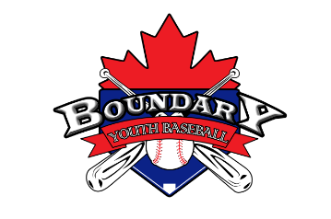
Boundary Youth Baseball
Volunteer- Code of Conduct Policy

The Boundary Youth Baseball Executives have mandated the following Code of Conduct.

All board members, coordinators, coaches, and team representatives will read this Code of Conduct and acknowledge that he or she understands and agrees to comply with the Code of Conduct.

No board member, coordinator, coach, or team representative shall at any time:

- Lay a hand upon, push, shove or threaten to strike a player, official or parent/spectator.
- Be guilty of heaping personal verbal or physical abuse on any official for any real or imaginary belief of a wrong decision or judgment.
- Be guilty of an objectionable demonstration of dissent at an official’s decision by throwing gloves, helmets, bats, balls or any other forceful unsportsmanlike action.
- Be guilty of using rough tactics in the play of a game against the body of another player.
- Be guilty of the use of profane, obscene, or vulgar language at any time.
- Appear on the field of play, stands or anywhere in the immediate area while in an intoxicated state.
- Be guilty of gambling upon any play or outcome of any game with anyone at any time.
- Smoke or vape during Boundary Youth Baseball events. Including in the stands, dugout or on the playing field. Please use designated areas.
- Be guilty of publicly discussing with spectators in a derogatory or abusive manner any play, officials’ decision or personal opinion on any players during the game.
- As a coach, be guilty of mingling with or fraternizing with spectators during the course of a game.
- Be guilty of tampering or manipulating any league rosters, schedules, official score books, rankings, financial records, or procedures.
- Challenge an umpire’s authority in an improper manner.
- Will not allow an uninsured person on the field during practices/games.
- Inappropriately use the internet or social media sites to disclose negative comments or question the integrity or credibility of a player, manager, coach, official or Association.
- Leave any player at the field alone and unattended.
- Bully/harass, speak disrespectfully to any board member, team manager, coach, official, parent/guardian, player or representative of the league.

The individual will be disciplined based on the severity which may result in a verbal warning, warning letter, suspension or dismissal from the association without a refund.

The Boundary Youth Baseball Executives hold the rights and will review all infractions of the Code of Conduct. Depending on the seriousness or frequency, the board may assess additional disciplinary action up to and including expulsion from the league.

Volunteer Contract:

I have read the volunteer code of conduct and fully understand all aspects. I have taken the time to consider my participation in the Boundary Youth Baseball Association and I agree to abide by all responsibilities noted in the volunteer code of conduct. I understand that failure to do so may result in my dismissal from the Boundary Youth Baseball Association.

Coach/Volunteer Name (print): _____________________________

Coach/ Volunteer Signature: ________________________________ Date: ____________________
President Signature : _______________________________________ Date: ____________________

