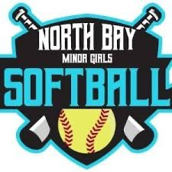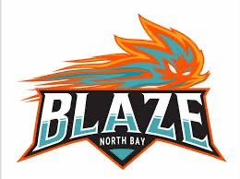

NBMGSA
House League Coaching Application

Please complete the following form and external documents and submit to pd_nbmgsa@yahoo.com no later than March 23, 2026
Contact Information
- Name of Applicant
- Phone Number
- Home Address
- Email Address
- Birthday
Do you have a daughter playing at that level?

Are you prepared to attend the Coach’s meeting (date in May TBD) and distribute a parent handout outlining League and team expectations for the season?
OPEN (19+)
U17
U15
U13
U11
U9
Please indicate for which level you are applying to coach:
Assistant coach
Team Application
Head coach

Police Vulnerable Sector Check (PVSC)
Date and results of your last Police Vulnerable Sector Check (PVSC). Date: Result: negative positive
If you do not have a current PVSC, within the last 2 years, you will be required to have one done. The Association is prepared to reimburse you the cost of having the PVSC done. Please email a copy of the receipt to bobcatbookkeeping@yahoo.com and a copy of the results to fastball1976@yahoo.com

Experience/Qualifications
How many years of coaching experience do you have?

Please provide details of your coaching experience

What does Fair Play mean to you?

Outline your approach to team management.

References
Reference 1 - Coaching Reference

- Reference Name

- Reference Email

- Reference Phone

Reference 2 – Non-Coaching Reference

- Reference Name

- Reference Email

- Reference Phone

I acknowledge and agree to the above-named references being contacted. I am aware that other persons and organizations may also be contacted. I give permission to these persons/organizations to provide information about myself to the North Bay Minor Girls Softball Association (NBMGSA) for purposes of this application.
Initials

THANK YOU FOR YOUR INTEREST AND YOUR WILLINGNESS TO VOLUNTEER YOUR TIME AND ENERGY TO SHARE YOUR TALENTS WITH THE YOUTH OF OUR COMMUNITY!

Please email this document to pd_nbmgsa@yahoo.com by March 23, 2026

