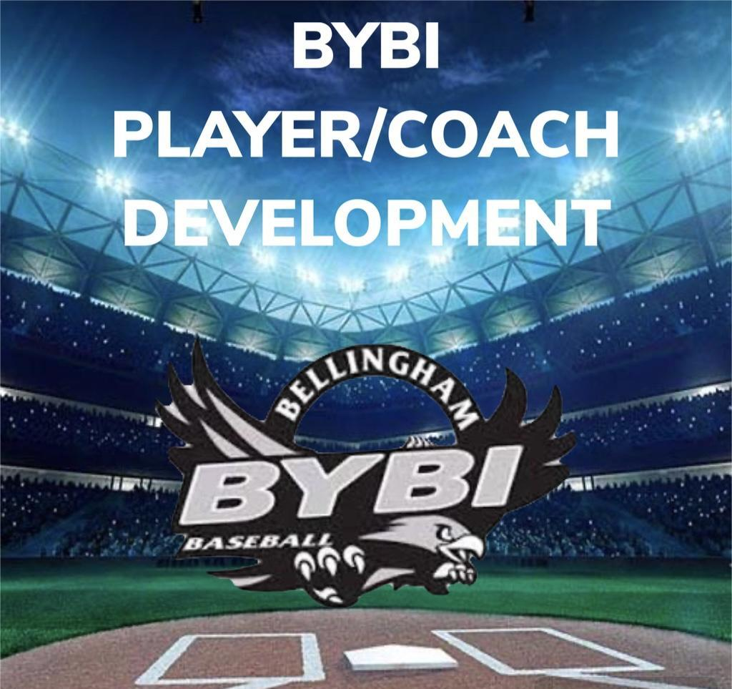
INSTRUCTIONAL
“BILL OF PLAYS” 2025

INSTRUCTIONAL: AGES 7&8

- Coach Pitch ½ season – Second ½ season using Pitching Machine.
  - Coach will shorten up the distance pitching to the batter between the mound and home plate – as the season progresses; the PM will be used at the pitchers mound to get a more lively reaction to hitting the ball.
- Defensive Ground Ball (GB) and Pop Fly (PF) progressions.
  - GB “Specials” routine at short distance with partner.
    - No glove roll ball back and forth in a good ready athletic stance.
      - Glove hand is extended out palm up – throwing hand ready to secure and bring into chest.
    - Glove on – same as above.
    - Short hops – work from the ground up.
    - Forehand and Backhand GB’s (back up and create distance)
    - GB shuffles, roll ball side to side and make partner move (create more distance) – based on reaction, partner will have to either use a backhand grab, forehand grab, or field it straight up.
  - PF footwork, catching the ball above your head, and creating momentum to throw the ball back in.
    - Instruct running for a PF on an angle, not back pedaling.
    - Use tennis balls for PF’s to build confidence for players to center body under ball to make a two-hand catch.
    - Teach the crow hop to create a strong throw back into the cutoff. (Always hit your cutoffs!)
- Pre-Game warm-ups - Team Stretching and Game planning.
    - Request to the parents that for ALL practices and games that players should arrive 15-20 minutes early in order to effectively warm-up as a team.

