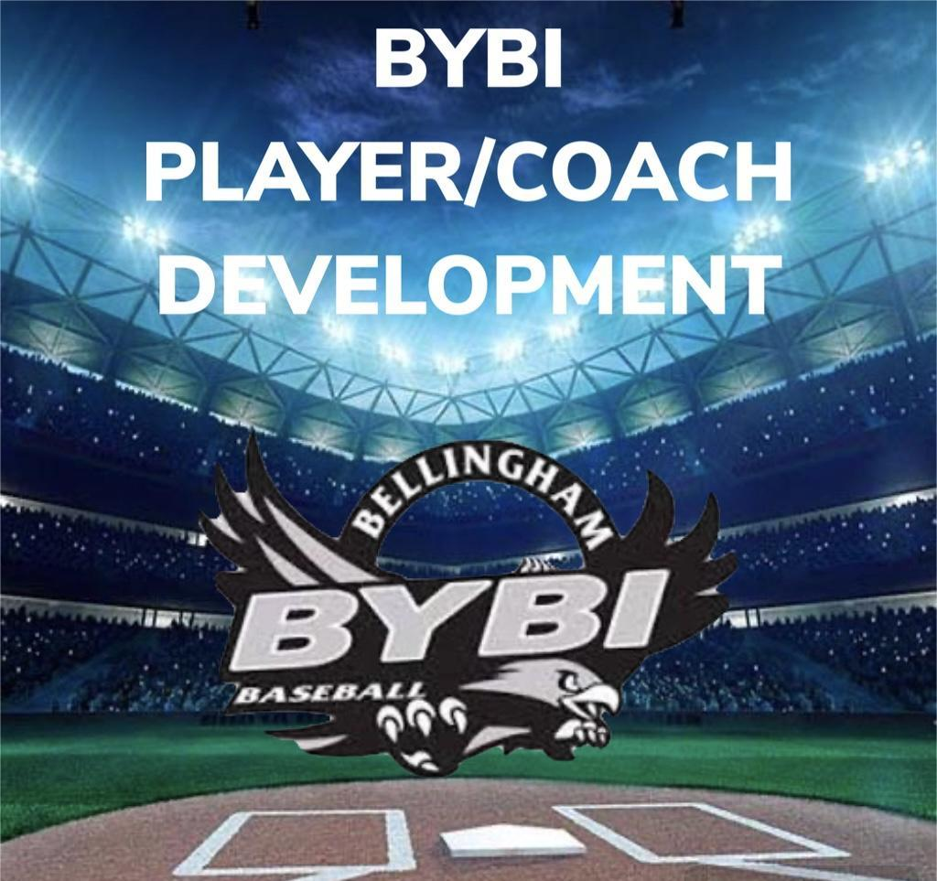

INTERNATIONAL
“BILL OF PLAYS” 2025

INTERNATIONAL (46-60): AGES 9-12

1. Reinforce Fielding Assignments
a. Players should know all assignments for all positions on the field.
- Infield/Outfield with a consistent rotation of positions and scenarios
b. Every player should know what he or she is doing with the ball before it is hit to them.
- Within the aforementioned Infield/Outfield, provide a scenario (1st and 2nd, 2 outs) and ask different players what their role should be depending on where the ball is hit

2. Bunting and Base running
a. Bunting basics, how to square, making contact, pulling the bat back on a ball.
- Always a fun one to end practice, make a game out of it! 5 points down the line, 3 points either side of mound, 0 back to pitcher.
b. Live coach pitch BP. Have an assistant at third giving signs and require the batter to call out what the sign meant before the next pitch is thrown
c. Basics of base running including stealing, tagging up, halfway on a fly ball, and sliding.

3. Pitching and Catching
a. All players should be taught proper mechanics and arm care.
b. The development of catchers must be a priority. Maintaining a proper rhythm between catcher and pitchers will help pitchers in-game.
c. Proper mechanics for catcher on throws to second and pick-offs.
- This can be incorporated with a base running drill. Have players practicing their stealing and “leading”, while allowing catchers time to try to throw runners out
e. How to receive a pitch as well as blocking wild pitches.
- Tennis ball drill: have players drop and block tennis balls with gear but no glove to help establish fundamentals.

4. Proper Warmup Fundamentals
- All players should know and understand a dedicated stretching routine
    - Each player should be able to and given the opportunity to leading stretching before practices and games
- All players should participate in warmup routines (structured “catch”) prior to every practice and game
- Players should start with short toss from knees, then same distance standing, then move back further, going back to about 60 feet to help build arm strength
- Coaches should emphasize the importance of strong throws from distance that may bounce once or twice, as opposed to “lollipop” throws

5. Reinforcement of the Fundamentals
- Players should be reminded of the fundamentals of fielding, throwing, and hitting
  - This should then be reinforced within the practice structure through basic infield/outfield drills with all players rotating positions to understand and train on these fundamentals
- Infield/Outfield with Live BP. Have players man each position with 3 hitters. Coach pitch with a catcher. Player hits and run out their swing. If they reach base, bring up another hitter to generate scenarios.

