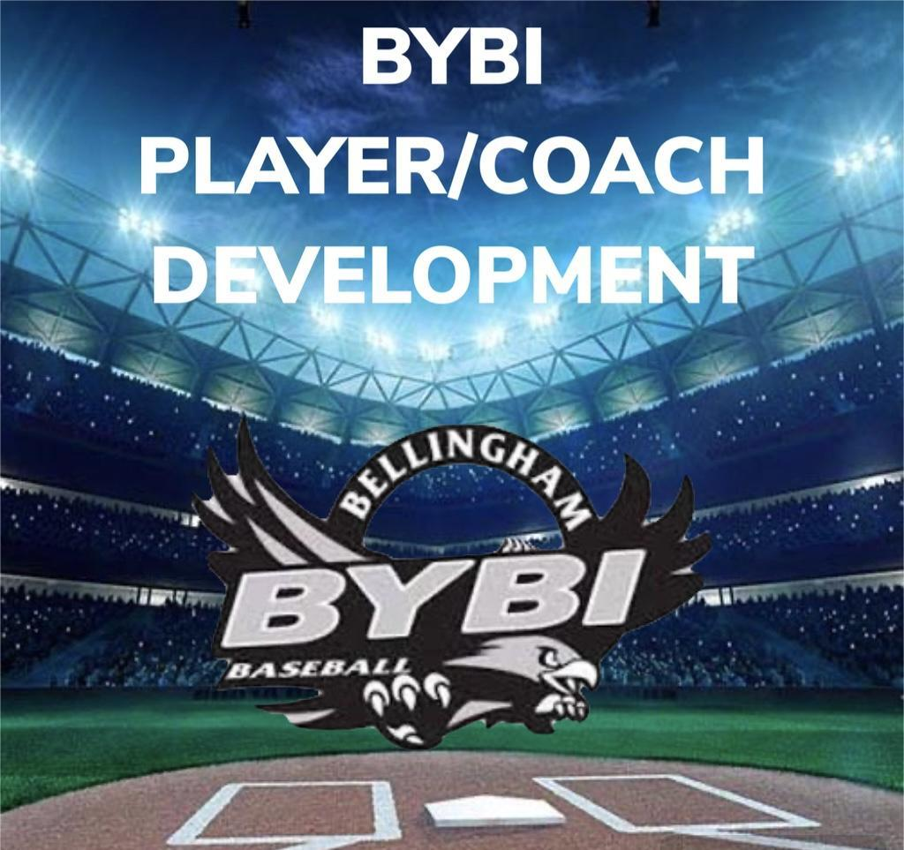
LIL’ SLUGGERS
“BILL OF PLAYS” 2025
LIL SLUGGERS: AGES 4-5

- Strong warm up routine before playing catch.
- Wait for the team and coach is present for throwing the ball around.

- Instruct proper throwing mechanics using Ready, Break, Throw.
- Help the players find grips on the ball and not palming it.
- 4-seam and 2-seam grips
- Train Tracks (2 Seam) Find the C (4 Seam)

- Hitting off the tee
- Help players with their grip and batting stance.
- Line up knuckles – don’t grip bat in middle of palm.
- bat off shoulder – hands should be level with ear.
- Knob of bat should be leading the swing – stay level – “check mark” swing.
- swing, not spin – front foot step towards the ball.

- Coaches and Players giving High 5’s.
- Make High 5’s for good performance and encouragement to teach players about good sportsmanship.
- Getting on base.
- Scoring a run.
- After a defensive inning.
- Picking each other up after an error or getting out at bat.

