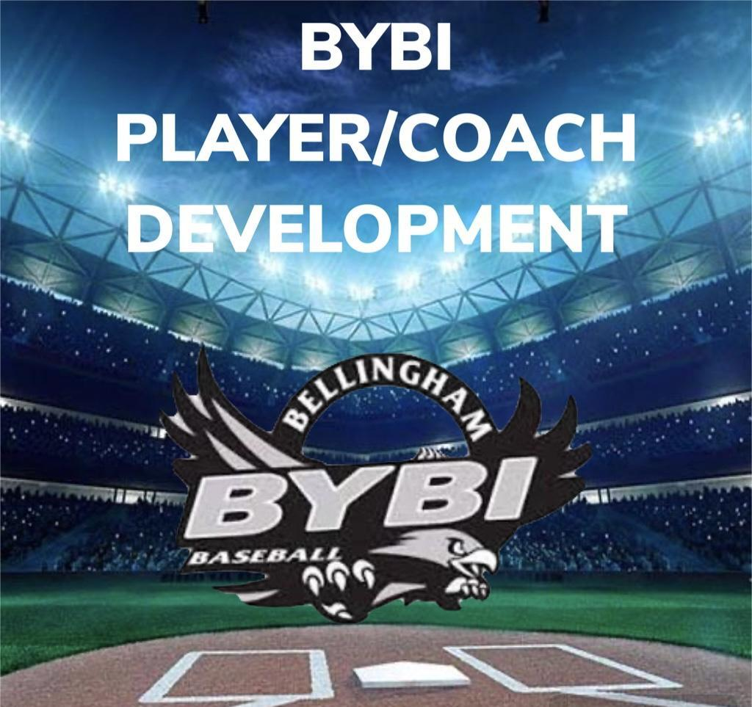
MAJORS
“BILL OF PLAYS” 2025

MAJORS (50/70): AGES 10-12

MAJORS (50/70): AGES 10-12

- Leading 1st base & 2nd base
  - Get your signal.
  - Wait for the pitcher to toe the rubber before getting off.
  - Lead:
    - Back right corner of the bag, shoulders facing next base.
    - Right, Left, Square….shuffle, shuffle (1st Base)
    - Right foot start – count to 4, Square….shuffle, shuffle (2nd Base)
  - Understanding baserunner roles, knowing when to take secondary lead vs. first move stealing when watching the pitchers delivery,
2. Develop leadership roles within the team
a. Can be practice leaders for stretching/warm up leadership.
b. Can be captains in right situation with experienced/deserving leadership type of players.
c. This will foster a sense of team sportsmanship and help develop a positive team culture year over year.

3. Encourage and teach pickoff moves/holding on runners
a. Build confidence through repetition in practice for all players (not just pitchers) on the various types of pick off moves.
i. Knowing when to come to a set vs. not coming to a set for a pick off.
ii. Varying move to home plate on each pitch.
b. 3 players at a time rotation Pick Off Drill. (1st, 2nd, 3rd, base)
c. Highlight picking off as a “pitcher” versus as an “infielder”
iii. Timed picks. (Defensive play calling cue)
iv. Defense plays in and out w/ runner (keeping them honest)

