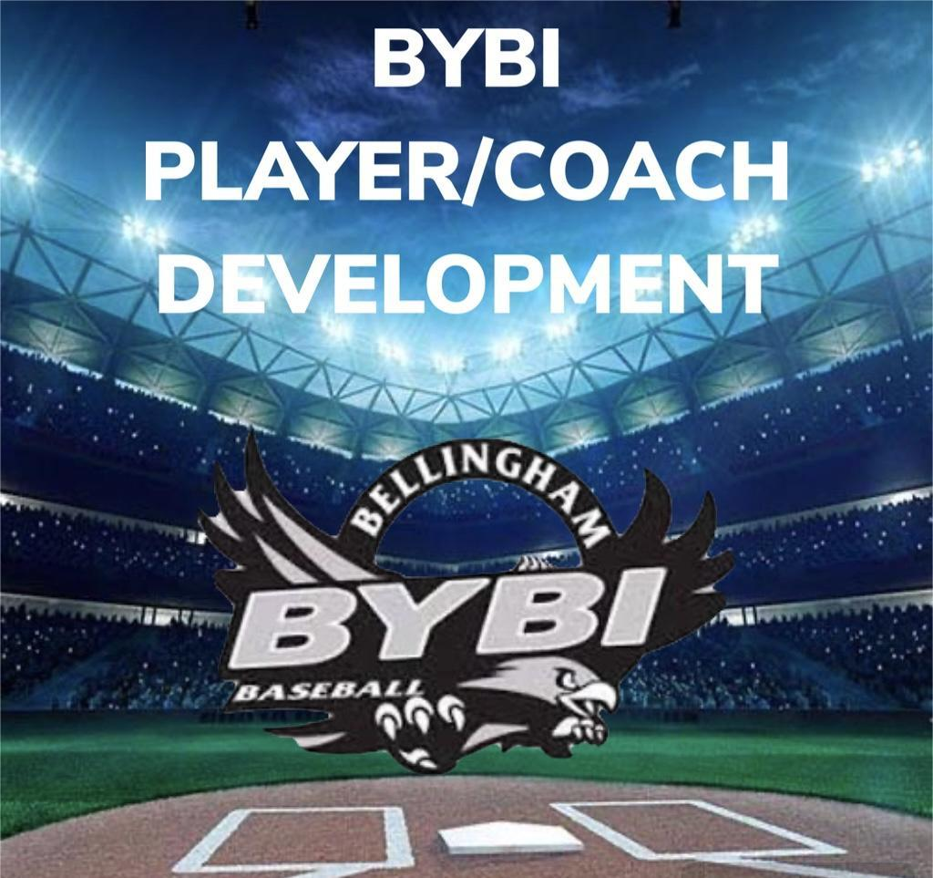
MINORS
“BILL OF PLAYS” 2025
MINORS: AGES 8&9

- Pitching Machine (4) games – Kids pitch the rest of season.
  - The minors league coaches will have the choice of using a pitching machine during the regular season for the games first 4 innings weeks 1-3.
  - The minors league coaches will have the choice of using a pitching machine during the regular season for the games first 2 innings weeks 4 into the playoffs
  - Playoffs will be all kid pitch
  - Mounds are moveable and should be moved by coaches to each players comfortable distance to allow the pitcher to reach the catcher.
  - Pitching needs to be a priority and practiced at each practice.
  - All kids should get a reasonable opportunity to pitch during the season.
  - A pitcher should be removed after 4 consecutive walks or 5 in an inning.

- Coach/Team huddle after every defensive inning.
  - Use this opportunity to construct defensive miscues and teach players a better way of approaching the situation.
  - Reinforcing a good defensive inning to get the players encouraged to have a good offensive inning.
  - Encourage players on offense to prepare (watching the pitcher, timing the swing, and ultimately to get excited and cheer on their team).

- Throwing Warm up example – all players each game and practice
- Close wrist flips, glove supporting elbow, 5 each.
- About 15 feet apart on one knee throwing to other player.
- Back up to 15 feet or so, Feet in mud drill 10 throws each Focus on Holding Follow Through.
- Move back to 30-40’ get into stride, Rock forward and back drill Focus on Holding Follow Through, 10 each.
- Back to pitching distance Lift and Hold for 3 seconds then throw, 10 each.
- Back up beyond 60’ and play catch until loose.
  - ***Bring back in to 30 feet finish it off with game of quick toss working on moving hands, footwork, and good quick throws, not too hard, quick on the transition!
- Pitching Drill Throwing Program.
  - Warm-Up (short distance) Utilize pitching from the stretch in ALL drills – keeps the body more focused and less movement than the wind-up.
    - Knee-up balance - hold for 3 seconds; break hands/feet, plant & throw. 5-10 times.
    - Start Knee-up balance, ball on ground across from foot, reach down and grab, back to balance point – Ready, break, throw. 5-10 times. (VIDEO: @ 2:12)
    - Knee-up using a baseball bucket in front of you, lift leg up to load hip facing target, drive leg down inside of bucket in straight line, follow through and finish throw. (VIDEO: @ 4:11)
    - Standing 1-Leg throws – plant leg down, rear leg bent 90 degrees – throwing arm elbow above shoulder, relax arm out and throw, with a bending balanced finish out in front. (VIDEO: @ 00:40)
  - Throwing and creating distance with your partner.
    - Wrist Snaps – Arm bent at 90 degrees out at a 45-degree angle from your body – glove under elbow, snap wrist. (6 feet)
    - Stuck in mud – lower body don’t move, rotate upper body and throw.
    - Weight Transfers – Small step back to load weight to back leg, follow through and throw.
    - Regular catch to long toss
      - Pull down throws on walking in on long toss.
- Coach Accountability
  - Coaches will be provided with practice plans for each of the games facets and will be EXPECTED to teach these during practices.
  - Coaches are mandated to have at least 2 practices per week. Not meeting practice minimums can result in losing team.
  - BYBI Resources will be available to coaches for their use in coach and player development.

