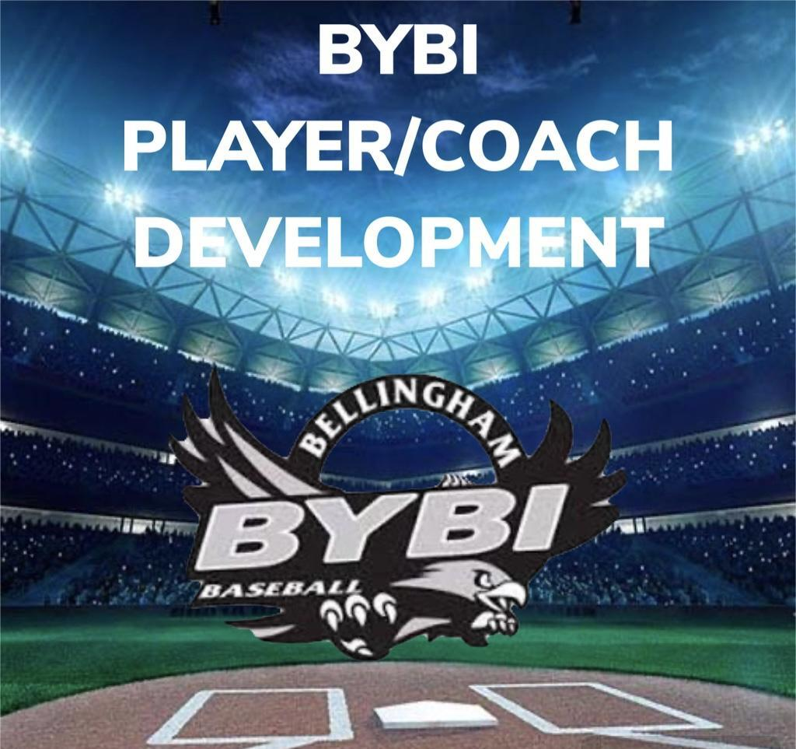

SENIORS
“BILL OF PLAYS” 2025
(Ages 13-17)

- Pre-Game Prep” Throwing and Dynamic Stretching
  - Thorough Static Stretching lead by designated team leaders with agility incorporated.
    - Coaches lead dynamic running drills – (shuffles, sprints, leads to steal sprints)
    - Progressional throwing routine. ( 2 knees, torso throws, weight transfers, regular toss to long toss – line drive throws to partner when moving in,
    - Playing catch with a purpose – utilize your preferred position to make game like throws with partner before long toss.
      - Infielders: simulate fielding a ground ball.
      - Outfielders: throw a pop-fly to yourself.
      - Catchers: secondary crouch position as if a runner is stealing.
      - Pitchers: Pick-off moves

- In-Game Scenarios and Playing With A High Level of Baseball IQ
  - Stealing: Proper lead – knowing what to look for when stealing a base.
  - Baserunning: Knowing how many outs – tagging up rule at each base.
  - Hitting: Hitting the ball where its pitched – Being discipline at the plate. Fouling of off speed pitches with 2 strikes to get a better pitch to swing at.
  - Pitching: Varying your move to first with runners on base – Utilize slide steps, holding for a pause – stepping off and resetting – Incorporating a good pickoff move vs. not your best move.
  - Catchers: Framing pitches – Being smart with pitch location when batter down 2 strikes.
- Pre-Practice/Game and Post Practice/Game Reflection with Coach
  - Asking questions about practice drills and game scenarios for improvement.
  - Bring up positive and negative impacts of the practice or game to work on.
  - Understanding that being responsible for your actions will help the teams comradery when you’re playing at your best, even when mistakes occur.

