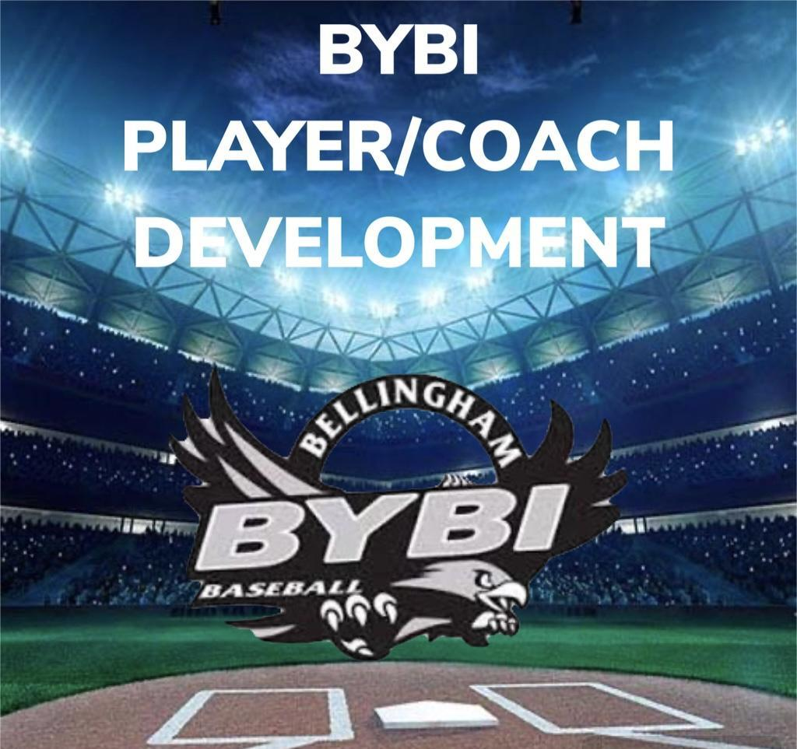
T-BALL
“BILL OF PLAYS” 2025
T-BALL: AGES 5&6

- Tees first ½ of season – second ½ coach pitch worked in.
  - Working on hand eye coordination of a still ball. Set the ball on the tee with the cross seams parallel to the batters eyes for them to focus on hitting it between the “train tracks.”
  - Building the confidence of the hitter through practices and games, coach will pitch at a shortened distance between the mound and home plate to the batter, or soft toss from the side.
- Running through 1st base drill
  - Player starts in the batter’s box with a bat, other players in a line behind them against the fence of the backstop.
  - Coach/partner acting as pitcher, goes through a wind-up without a ball for every hitter
  - Cone set up 10 feet behind 1st base.
  - The batter swings, drops the bat, and runs all the way through 1st base, striking the front of the bag with their foot.
  - The runner slows down after crossing the bag, breaking down at the cone using wide feet, short choppy steps, and looking towards the 1st base side fence to see if the ball was over thrown.
  - Once the runner comes to a stop, they jog back to home plate to get back in line.
  - Each player rotates through the line so that they each run all the way through 1st base 5 times.
- Tennis balls playing catch and for pop fly’s.
    - Early in the season and for practices, reinforce having the player catch the ball in the center of their body without having to step to the side away from the ball. Build their confidence up to transition to a cushioned ball.
    - Work on stationary pop fly’s to the player, getting squared under the ball, making the catch above their head and using two hands.
- Ground ball drill progressions.
a) Teach a good ready athletic stance where they don’t sink down to the ground to field a ground ball, or stop it with their glove.
  - Should we start with a tennis ball and no glove to field with bare-hand using good form.
  - Roll ball back and forth to partner with glove out, and throwing hand ready to secure and bring into chest.
  - Work the players to shuffle back and forth to react to the ball not directly hit at them.
  - Fielding a GB and making the throw to 1st base.
5. Make sure shoulders are squared to your target.
- Avoid where players stand up and make a throw with their legs locked in place.
      - Create momentum to your target.
      - Follow through and finish your throw.

