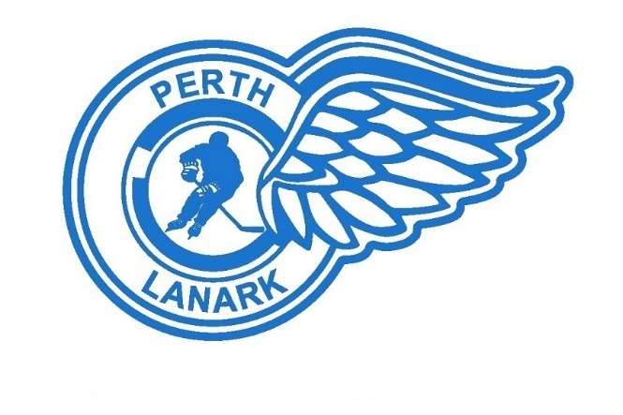
PLMHA Website Release Form
PLMHA currently runs a website (www.plmha.ca) with the ability to upload team and individual photos and stats. Every player under the age of 18 must have a release form returned to the association BEFORE any information or photos can appear on the website.
Please be advised that the executive of the PLMHA makes every foreseeable effort to keep the kids safe on the website and as a result, no personal information other than the names of the players will appear on the site.

20__ - 20__ Season

☐ I give permission or ☐ I DO NOT give permission
to have my child’s name and or photo appear on the Perth Lanark Minor Hockey website for the season indicated above. I understand that by signing below, I release the Perth Lanark Minor Hockey Association from any unintentional liability associated with their website.

______________________ ________________________ ___________________
Player’s Name Team (i.e. U7 B) Coaches Name

______________________ ________________________ ___________________
Parent/Guardian (printed) Signature Date

______________________ ________________________ ___________________
Parent/Guardian (printed) Signature Date

