2018 News Archive

2018 OSBA Cup Championship RESULTS
WHITBY CHIEFS vs. SCARBOROUGH DRAGONS
Game #1
Chiefs - 5 Dragons - 4
WP - Mike Bannon LP - Pete Westlake
Game #2
Chiefs - 7 Dragons - 2
WP - Chris Wotten LP - Pat Janssen
Whitby leads series 2-0

2018 OSBA Player Awards
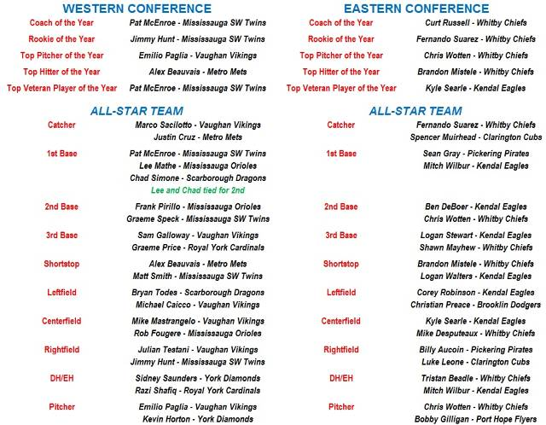

Orioles battle hard in Port Lambton Tournament
The ‘Wounded Orioles of 2018’ took part in the annual Port Lambton Pirates A Senior Baseball Tournament this past weekend. In true 2018 fashion they had a full complement of players and in 1 game actually had a sub on the bench! Something rarely seen in OSBA play this year.
Game 1 - Friday vs Corruna Giants (Loss - 6-3): The Orioles once again requested the assistance of fellow OSBA player Harrison Gaudet to accompany them in Port Lambton and it was nice to have Harrison on the same side of the field as opposed shutting them down on the mound early in the season with Royal York. With a run in each of the first 3 innings Corruna jumped out the early lead. However in the bottom of the third the Orioles capitalized on a couple errors and a 2 out double by Lee Mathé drove home Joel Palma to make the score 3-2 heading into the 4th. After getting the first two outs in the fourth The Orioles looked poised to have shutdown inning but the Giants managed to cash in on a couple Orioles mistakes and score 2 runs making the score 5-2. The Giants only managed to push one more run across over 3 effective innings pitched by John Brady making the score 6-2 heading into the bottom of the 7th. The bottom of the Orioles order had a very effective game and with hits by Darryn Renaud, Rob Fougere, Brady and a walk by Gaudet the Orioles had the tying run at the plate with one out and runners at 1st and 3rd. However a snap throw to first caught a leaning Oriole and a strikeout ended the comeback and the Orioles fell short in game 1.
Game 2 - Saturday vs. Port Lambton Pirates (Loss 8-2): The score does not tell the whole story in this game. The Orioles now down to 9 players for Saturday turned to Darryn Renaud to give them a quality start, and they definitely got that and more. In his first pitching action of the year Renaud managed to effectively work his way through 7 innings to give the Orioles a chance. Some fantastic defensive gems from Frank Pirillo and Joel Palma up the middle and countless balls tracked down in the outfield by centre fielder Rob Fougere kept the score at 4-2 heading into the top of the 5th inning. Renaud back out for the 5th managed to pitch his way out a bases loaded 1 out jam getting a ground ball he needed inducing a 6-4-3 double play to get out of the 5th. Renaud hampered by a hamstring injury limiting his mobility and speed decided to hit from the right side in his third plate appearance of the game and with a runner on second base with 2 out Renaud managed to tattoo a ball right up the middle knocking in a run for the Orioles making it 4-3 heading to the 6th. A scoreless 6th on both ends took us to the 7th inning still with a 4-3 score. This is where perhaps playing the hometown team maybe went against the Orioles and a few questionable balls and missed strike calls led to 4 walks and a 2 out single brought home 2 more big runs for the Pirates making the score 8-3 heading into the bottom half. The Orioles determined not to go down without a fight led off the inning with a HBP for Mathé, a single by Rattray (3rd of the game), a passed ball and a walk by Avi Sundar had the bases loaded with 2 outs. It was however not to be and 2 shallow pop outs ended the game and thwarted another potential Orioles comeback.
Game 3 - Saturday vs. Tecumseh Thunder (2): With the temperature now sitting at a scorching 38 degrees the Orioles had their destiny sitting right in front of them with Joel Palma slotted to pitch and the winner advancing to the quarter finals on Sunday morning, the only obstacle was the tecumseh thunder. The Orioles bats came alive in this tilt jumping out to a 1-0 lead in the first and a leadoff walk in the second by Rob Fougere, a steal of second, a steal of third and a sac fly made the score 2-0 heading into the bottom of the second. Tecumseh managed to string together 5 straight hits in the bottom half to knot the score up at 2 heading into the 3rd inning. The Orioles led off the inning with singles by John Brady, Brandon Sekulovich and Joel Palma had the bases loaded with none out with Frank Pirillo up. Prillo promptly knocked a bases clearing double to the fence and Mathé making it back to back doubles extended the Orioles lead to 6-2 heading into the bottom half. A shutdown inning in the 4th brought Rob Fougere back to the plate where he lead off the inning with a triple that was inches away from clearing the top of the fence in left centre field. Making the score 7-2. This is when Tecumseh’s bats came alive again coupled with some untimely errors by the Orioles and 4 base hits the Thunder knotted teh score up at 7-7. Bottom of the 6th saw the Orioles one pitch away from getting out of a bases loaded none out jam, but it was not to be and a ball in the dirt at 1st base led to 2 unearned runs from the Thunder nevertheless making the score 9-7 heading in the top of the 7th. Mathé led off the inning with a walk, Rattray got his 6th hit of the day to give the Orioles 1st and 2nd with none out. A pop fly and a passed ball put the tying run on 2nd base and Avi Sundar at the plate. Sundar did his job and hit a fly ball to right field Mathé tagged up at 3rd and with a hook slide avoiding the tag managed to cash in the sac fly making the score 9-8 and the tying run now at 3rd base. A hard hit ball up the middle looked like it would tie the score but a defensive gem by the Thunder Shortstop ended the game and the Orioles chances in Port Lambton with a 9-8 final.
Great work all around for the Orioles battling hard with 9 players. Injuries have been the story for the Orioles thus far but with positive performances by all players at the tournament the Orioles hope to change the narrative of 2018 and return to OSBA action against the expansion Mississauga Majors Sunday afternoon for a 1PM start for their doubleheader.

OPENING WEEKEND
Well Opening Weekend is finally here! A total of 4 doubleheaders will get the 2018 OSBA season going with a bang.
The Western Conference gets the bulk of the games today with 3 DH's. The Vaughan Vikings will kick the season off at 1:00pm as they visit the new expansion Mississauga Majors. This will be a very strong test for the new Majors squad that is moving up from the Junior Select ranks. Next in the West will see the Metro Mets visiting the Mississauga Southwest Twins. This should be a very tight battle in both games as these two teams are pretty evenly matched. Finally the third DH in the West sees the Mississauga Orioles hosting the Royal York Cardinals. The Cardinals hope to move up in the standings this year and that road starts with a touch opponent in the Orioles.
In the loan Eastern Conference doubleheader long time rivals the Clarington Cubs and Whitby Chiefs will do battle up at a neutral site in Kendal. Several other DH's needed to be rescheduled due to a rash of diamond issues due to the severe weather storm that passed through a few weeks ago.
This should be a great season and with great weather today it will also be a great start to the season.

OSBA WELCOMES NEW TEAM FROM MISSISSAUGA
The Ontario Senior Baseball Association are proud to announce that they have added a new team from the Mississauga Majors organisation. The team will be the 15th team in OSBA for the upcoming 2018 season. The league lost the Mississauga Braves and Bowmanville Bandits over the winter lowering the number of teams in OSBA to 14. So the OSBA Executive were very happy that they received the Majors application for entry.

However just because the league was looking for new teams, didn't mean that the Majors would get in without a good vetting process by all team members present at the meeting. So Majors head coach Louis Milojevic made a very good presentation and then took questions from the OSBA coaches.

It was revealed that the team originated from the Select ranks and were originally from the Mississauga Southwest Twins association. However with OSBA already having 4 teams playing out of their old 9th Line park and the fact that OSBA already has a Mississauga Southwest Twins team, they decided to see what other opportunities were available in Mississauga. The Mississauga Majors association President Tony Jasinski was more then happy to give the team a home. They will play at Valleys and look to be playing on Sunday afternoons at home.

The major concern brought up by a few coaches was the fact that OSBA had added teams from the Select level in the recent pass only to see those teams last a year and then disappear. Louis assured the Executive that not only was he committed to the team for a minimum of 5 years but the players are here to play and have fun and work towards being one of the stronger teams. They understand that things could be rough the first year or two but are willing to put in the work to become a strong member of OSBA.

OSBA welcomes the Mississauga Majors to OSBA for the 2018 season!

