2019 News Archive
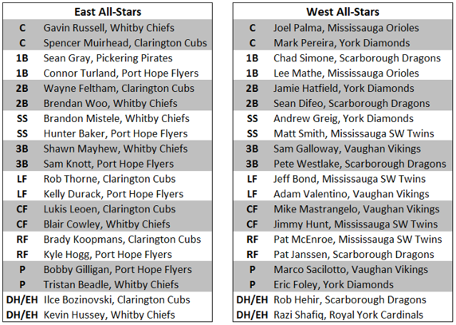

WHITBY CHIEFS 2019 OSBA CHAMPIONS
The Whitby Chiefs swept the Vaughan Vikings to win their second OSBA CUP in a row and their THIRD Championship overall.
The MVP for the Championship series was #44 Gavin Russell (Whitby Chiefs)
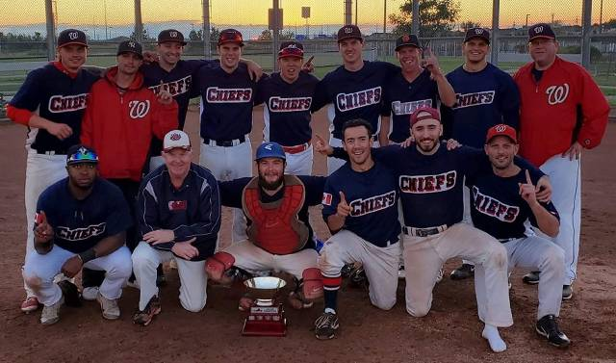

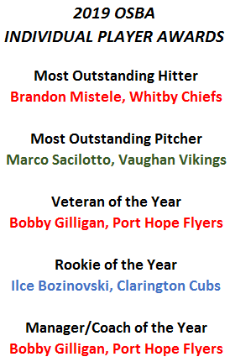

2019 OSBA CHAMPIONSHIP SERIES SET
The 2019 OSBA Championship series has finally been set after the Whitby Chiefs defeated the Clarington Cubs in three games to claim the Eastern Championship and earn the right to face the Vaughan Vikings who won the Western Championship last weekend and have been sitting patiently waiting to see who they would be facing in the 2019 OSBA Championship best of 5 series.
The series will get started this weekend with the Chiefs hosting the Vikings on Sunday September 22nd at the Ajax Sportsplex. Game times will be 5:30pm and 8:00pm (approximately).

2019 Orioles have their best showing at the OBA B Championships
Game 1 vs. Lakeside Lizards – The Orioles took on a familiar opponent after winning by mercy in
2018 the Orioles once again drew Lakeside this year for a Friday evening contest. The Orioles
turned to pitcher Walker Lewis for this contest and he did not disappoint and Lewis manged to
pitch himself out of a bases loaded jam in 4 of the 7 innings. The Orioles fought from behind
twice to jump out to a 5-1 lead heading into the top of the 7 th . After getting the first out in the
bottom of the 7 th Lakeside managed to get 5 base runners on in a row and even managed to get
the go ahead run at 1 st base but Lewis recorded his 9 th strikeout to end the game and securing a
5-3 win for the Orioles, a Saturday afternoon game against the host Port Lambton Pirates but
more importantly a 1-0 start!
Notables: Walker Lewis – 7 IP, 2 ER, 7H, 9K
Game 2 vs. Port Lambton Pirates – The Orioles had only faced the Pirates once over the past 5
years and it resulted in a loss so the Orioles were eager for another shot at redemption. With a
win securing them a bye into Sunday morning the Orioles turned to the same pitcher they have
for the past 2 seasons Joel Palma. It was anything but a breezy start for Palma as he gave up 3
runs in the first 2 innings, but no amount of unruly fans, foghorns and home town calls would
slow him down. But unlike some outings in the past Palma received more than enough run
support and thanks in large part to a 6 run bottom of the 2 nd the Orioles managed to chase the
Pirates starter after just 1 and a third innings and jumped out to an 8-3 start. Nic Parker came in
for 2 innings of nearly flawless relief and the Orioles tacked on 2 late runs to take Game 2 10-5,
and receiving a third round bye into the undefeated game on Sunday morning.
Notables: Joel Palma - 5 IP. 3 runs scored and 2 hits
Darryn Renaud – 3 hits, 1 run scored
Game 3 vs. Woodslee Orioles – It was a rainy Sunday morning and perhaps that was what
affected the Orioles play but whatever it was they could not muster enough offense to ever
threaten one of the other 2 Orioles teams in the tournament. Even battling a muddy round and
what seemed like needing to clean off his cleats every other batter starter Nic Parker pitched a
strong 4 innings but never got the offensive support to cash in on the strong start. Weather
conditions only got worse but the game got in before the tarps came out and it resulted in a 6-0
loss for the Orioles meaning they were set to play the London Angels later that day in a semi
final do or die game.
Game 4 vs. London Area Angels – As noted earlier the rains came and it forced a 7 hour rain
delay in Port Lambton and an elimination game between the Clearview Orioles and the Port
Lambton Pirates. This meant that the final 4 round could not start until this game ended and
when the game did not start up again until 530 PM that evening it pushed the final 4 back until
9 AM Monday morning. On 2 days rest the Orioles once again turned to Joel Palma, the Orioles
also however were battling a depleted roster and the absence of play on Sunday meant 5
Orioles had to head home leaving them with only 10 players. Not willing to make excuses
veteran leader Frank Pirillo provided a pump up speech for the ages and Palma came out on fire
pitching 3 scoreless innings. The Orioles however once again struggled to muster early offence
and it was 0-0 through 3 innings. The 4 th inning saw some bad luck and 2 bloop singles and a
pop-up bunt which landed just out of the reach of diving first baseman Lee Mathé left the
Orioles facing a bases loaded none out jam. This is where some clutch hitting for the Angels and
a couple errors left the Orioles on the wrong side of a 6-0 deficit. The top of the 5 th saw the
Orioles get 4 straight hits and 2 runs to cut the deficit to 6-2 and force a pitching change and
still the bases loaded and only 1 out. However maybe it was a turning point in the game to
change pitchers and the Angels managed to escape the jam and thwart off any further offense
from the Orioles and end the title aspirations. It was however the Orioles best ever finish at the
B championships and a 3 rd place finish.
The Orioles after playing 4 games in 4 days left battered and bruised, sustained a few injuries
but hope to keep their bounce back year going with a wildcard matchup this Wednesday
against the Mississauga SW Twins in OSBA play.

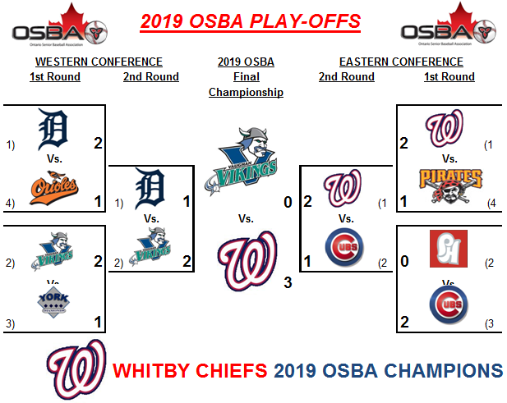

OSBA teams to take part in OBA's this weekend
The Ontario Senior Baseball Association is proud to announce that three of our teams will be taking part in three OBA tournaments this coming weekend.

VAUGHAN VIKINGS "AA" - The Vikings are the host for this tournament and are looking to continue their strong play this season right to an OBA Championship. The strong pitching staff led by Emilio Paglia and Marco Sacilotto should carry them in to the finals.
MISSISSAUGA ORIOLES "B" - The Orioles are hoping for a much better result this year after injuries threw a wrench in to their OBA aspirations in 2018. Head coach Lee Mathe has put together a strong and healthy roster.
PORT HOPE FLYERS "C" - The Flyers are the surprise of OSBA this year, holding down 2nd place in the Eastern Conference. Head coach Bobby Gilligan has bolstered his pitching staff this year, with him and Brandon Tink making a solid 1-2 punch.
We wish all three teams Good Luck this weekend!!

2019 Mississauga Orioles Preview
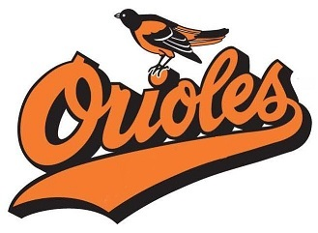The Mississauga Orioles are looking forward to rebounding after a tough season last year after finishing 7-18-1. The Orioles had made serious strides in 2017 making it to the Western Conference Final and had high hopes of matching or bettering that feat. But key injuries to Mike Cappucitti and Mike Shuryn left the Orioles in need of catching help. Also with newcomer Walker Lewis moving to Vancouver for work the Orioles were also treading water in the pitching department.
The Orioles as they have in the past rallied around each other in the late season to make a deep run in the new B championship managing to sweep the competition in the West. It was not to be however as they eventually lost game 3 of the best of 3 Final to Clarington Cubs 2-1 in a pitcher’s duel.
Capp (recovered from surgery), Shuryn and Lewis are all ready to return this year and the Orioles hope to return back to their 2017 form and hopefully not stop there. The Orioles hope to make a deep run at OBA Championships this year as well. Their location is TBD as they will classify early July.

2019 Scarborough Dragons Preview
The Scarborough Dragons 2018 season finished off with a tough pill to swallow as they went down in three straight games in the OSBA CUP to their rivals from the East, the Whitby Chiefs. This after finishing the regular season with the best record in OSBA at 23-2-1. It was their 5 consecutive appearance in the OSBA CUP since their arrival in OSBA in 2013, having won it three times and were hoping to become the second four time OSBA Champion.
The Dragons head coach Adam Johnston went in to the off-season not so much looking for new players, as much as he was looking to get some of their regulars back healthy. They lost nobody and gained no new guys, however they will have a healthy Tim March and Rob Hehir back so their pitching staff will be that much stronger in 2019 than it was in 2018. Also looking to bounce back from an injury plagued season will be Tyler Shortt, Dev Connelly and Pat Janssen.
The one upside to the pitching injuries in 2018 was that the Dragons were able to discover Chad Simone and his ability to throw strikes and win games for them. This will be concerning to the rest of the league, as it will just add to the Dragons mound depth.
So heading in to the 2019 Season the Dragons goal as it always is, will be to win the OSBA CUP and this year become its second four time winner!

2019 Bowmanville Dodgers Preview
The Brooklin Dodgers managed by league founder Rodney Holinaty are looking to put a very dismal 2018 season behind them. So after going winless during the OSBA Regular Season (0-26), winless on their trip to Montreal (0-4), winless in the inaugural OSBA “B” Championship playoffs (0-2) and even though they finally turned the corner with a win and a tie in their own fall tournament (1-1-1), it was decided that changes needed to happen. So after playing the entire 2018 season on the road, they decided to plant down roots in Clarington with a new home field and new home team name. Going forward starting in their 19th season in OSBA, they will be known as the Bowmanville Dodgers and play the majority of their home games at Clarington Fields NW and SW.
Along with a name change and new home field, there were also some player departures, as the Dodgers said goodbye to James Wowk, Todd Mogavero, Paul Mogavero and several part time players. The Dodgers added several players in the off-season with great versatility, adding both youth and experience in Kyle Hall, Dave Fischer, Simon Qaqish, Andy Rudback as well as welcoming back Michael Ross after a year away out west. The possibility of adding a couple of more young players brought on by Sebastian Holinaty is still in the works.
The Dodgers expect to have a much improved season in 2019 and will be shooting for a spot in the OSBA Cup playoffs. They will also be making a return trip to Montreal at the end of July in the hopes of improving their result there as well.

2019 Clarington Cubs Preview
The 2019 Clarington Cubs will be entering into their 19th season within the OSBA under new management with first year player-coach Luke Leoen, taking over for Chris Killoran who ran the team from it’s inception.
The Cubs look to improve on last year’s 15-10-1 record which placed them 4th in the Eastern division that lead them to face the Port Hope Flyers in a one game wild card playoff game. After an intense and hard fought game between both teams, the Flyers pulled off a walk off win in the bottom of the 7th inning which relegated the Cubs down to the B playoff bracket where they went on to defeat the Brooklin Dodgers and Mississauga Orioles to capture the inaugural OSBA B Championship title.
The biggest departure for the 2019 will be the loss of playoff MVP pitcher Bart Haberling, who’s decided to hang up the cleats. His leadership and ability to dominate on the mound will be missed. Heading into 2019, the Cubs are excited for the additions of newcomers Ilce and George Bozinovski, Joey Medhurst and Josh Chaulk plus returning veterans to help the team improve on what was a successful 2018 season.
In addition to the OSBA regular season and playoffs, the Cubs will look to have another strong showing at the Peterborough Civic Tournament in August, as well as trying to bring home the Senior A OBA Championship this September.

2019 Vaughan Vikings Preview
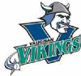The Vaughan Vikings coached by Morty Fergenbaum, were tied for the second best record in OSBA in 2018 (22-3-1) with the Whitby Chiefs. They would sweep the Mississauga Southwest Twins in the First Round of the OSBA play-offs but after winning game #1 in the Western Conference Finals against the Scarborough Dragons, they would lose games two and three to end their season.
The Vikings had a very quiet off-season losing only Seth Anon and adding no new players. They would start their indoor workouts at the Vaughan Sports Centre in Kleinberg at the end of February.
With their solid roster still intact the team is looking forward to another successful run during the regular season that will end with their second OSBA Cup championship. They will also be hosting their annual Vaughan Senior Tournament on the weekend of June 14-16. They are also hosting the Baseball Ontario Provincial Senior AA Tournament on Labour Day weekend.

2019 Pickering Pirates Season Preview
After a fairly successful regular season (2nd place 16-8-1), the Pickering Pirates ended 2018 on a very sour note. After reaching the Eastern Conference finals against their arch-rivals from Whitby Chiefs, the Pirates lost game 1 in a nail-biter and then went on to get swept in blowout fashion in game 2.
With the memory of that defeat still in their minds, the Pirates are back and itching to go for the 2019 season. While the majority of the roster is still intact, the Pirates most noticeable change this season will be the absence of long time ace, Brad Binns. However, the team is hopeful to bring some of the old magic back with the return to health of gold-glove centerfielder Matt D’Souza and slugger Scott Gray, both of whom missed all of 2018 with achilles injuries.
With some of the new additions from 2018 staying around for 2019, the Pirates will once again rely on grittiness, good health and veteran leadership to make another run at the OSBA title.

2019 Mississauga Southwest Twins Season Preview
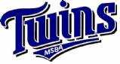The Twins finished 2018 with a 15-10 -1 record, good for a third-place finish in the Western Conference and then for the eighth year in a row they were quickly bounced from the first round of the playoffs.
As for roster moves, longtime Twin Nimesh Shah decided to hang'em up after 2018 and with a new baby on the way Dave Robinson and his wife have moved back to Kincardine. In terms of a additions, they have added former Mets outfielder JP Caissy and pitcher Tom Malyk is also contemplating coming out of retirement to rejoin the Twins.
Beyond that, the Twins will return essentially the same roster with reigning Western Conference Rookie of the Year Jimmy Hunt and Veteran of the Year Pat McEnroe, All Stars Matt Smith and Graham Speck, as well as perennial MVP candidate Jeff Bond will continue to be anchoring a lineup that produced one of the highest scoring offenses in the OSBA last year.
The Twins goals for 2019 are to make one last run at the annual Civic Holiday Peterborough tournament and to have 13 healthy players for the playoffs.

2019 Port Hope Flyers season preview
The 2019 Port Hope Flyers will be entering their 8th season within the Eastern Conference of the OSBA. With OSBA going back to the "Cross-over" games against the Western Conference teams this season, the Flyers will face teams that they have never played before. The new challenges brings a whole new excitement and twist to the team and the league.
The Flyers finished 5th in the Eastern Conference last season and this allowed them to get a chance to play in the Wild Card game against the 4th place Clarington Cubs. Again it was another new twist brought into the OSBA last season and it didn't disappoint as The Flyers would score 4 runs in the 7th inning to win the game 4-3 and move on to face the 1st place Whitby Chiefs. The Flyers shocked the OSBA world and won the 1st game but Whitby was too much and took the next 2 games and eventually went on to win all of their playoff games to take the OSBA title.
The Flyers went into the off season looking for youth, pitching and to upgrade their defense. But shocking news came after Christmas, that 4 regular players where calling it quits including long time CF Robert McNab who could win games with his bat, his defense and his pitching. Also, 1 core starting pitcher left for another team within the OSBA which hurts their pitching depth this season. The Flyers recruiters worked hard and eventually brought in some new talent from around the area. Adding 6 new players including 3 young players from the Peterborough area, Doug Loucks, Shane Patterson and Lee Condon who will help this team in all aspects of the game.
There still remains some household names for The Flyers. Cory Baker, Tye MacInnes and Jake Tuomenin are the longest serving Flyers and will be expected to lead these young guys moving forward. Bobby Gilligan will be expected to carry a heavy workload again on the mound and Hunter Baker looks again to lead this team offensively.
The Flyers have lost a lot of core players over the past couple of years which has put this team into the "Rebuilding" stage. With additions to the 2019 Flyers, the expectations are high and are looking forward to the 2019 season kicking off in May.

Highlights from past meeting
On Sunday April 14th the OSBA held their last meeting before the regular season starts in May. All teams were represented, though West VP Lee Mathe was absent.
Webmaster Rod Holinaty gave an update on a possible new website for the league. He gave it a thorough investigation and while it did have some very appealing items, such as an App for the league it had several shortcomings. He felt it was a barebones website that would be good for managing a team but did not have all the items that we needed. Rodney is also looking into getting our own domain name to make it easier for people to find the website.
Teams that are getting their insurance through OSBA were reminded by Treasurer Brendan Forbes how much it would be and that payment was due. Teams that are insured through their local association affiliation were reminded that they needed to get their letters of Proof of Insurance to him ASAP. All teams were also reminded on the amount that they owed for their league registration fee and that it too was due ASAP.
Baseballs that were purchased through Bobby Gilligan were distributed after the meeting as well as Line-up card booklets.
Paul Freeman gave an update on the schedule that he and Rodney Holinaty are constructing. The target is to have all park dates by Thursday April 18th (currently two teams still waiting to get them) and to have the schedule completed that night, with the weekend to go over it and make sure it is sound.
A discussion of how the Disciplinary Committee would work was held and everyone was informed that the two VP’s will select three coaches to vote on the committees as each incident comes up. This will alleviate the issue of a coach involved in the issue before the committee, having to excuse themselves from committee, if already on it.
A discussion on the best method to use for deciding the awards was held. It was decided to keep the awards East & West but the major awards will be for the whole league MVP, etc... There will be two votes per team, coaches plus one.
Teams gave updates on their current status and there were no major issues with the exception of the two teams waiting for diamond time.
The meeting was adjourned and the teams all look forward to seeing each other on the field starting the May 4th weekend, as long as Mother Nature agrees.

2019 York Diamonds Preview
With the start of OSBA's 19th season less than a month away, it's time we reintroduce an old feature that we haven't had in a few years. Over the coming weeks we will be posting up previews for each of the eleven teams that will be taking part in the 2019 season. The previews will be in no specific order but we will try and alternate between the Western Conference and the Eastern Conference.
We will start our previews off in the Western Conference with long time league member; the York Diamonds who are coached by Paul Freeman.
The Diamonds finished off the 2018 regular season with a 12-13 record giving them 4th Place and home-field advantage in the Western wild card game for the last playoff spot, they played the 5th place Royal York Cardinals and defeated them by a score of 7-0. They then had the daunting task of taking on to Scarborough Dragons and were swept in their best-of-three series.
So going in to the off-season Coach Freeman was planning on cutting down on the number of part time players and getting guys to give a stronger commitment to the team. They would lose a few key players such as; Justin Williams, Tommie Haslett and Pete Saweczko but on the flipside they would add some solid players, including some from the defunct Metro Mets; Alex Beauvais, Clint Jeon, Marshall Irving and Jamie Hatfield. Steve Correia also returns after a year off. These additions will definitely make them stronger especially the addition of Irving as he had the Diamonds number in 2018, so they will be very happy to have him throwing for them in 2019.
The team has just recently started indoor workouts at the Baseball Zone.
With their new additions they are confident of improving their record from last year and being an over .500 team and also they look to go much deeper in the OSBA Cup playoffs. As well a large contingent of the team will be taking part in an 0ver-35 tournament during the summer.
On a more somber note the York Diamonds would like to dedicate their 2019 season to the memory of Pete Zakkak. Zak was a long-time Diamonds player and was the groundskeeper at their home park of Keelesdale. He will be sorely missed by all those who knew him on and off the field. To view tributes to Zak, please visit the teams’ website at http://www.yorkdiamonds.ca

Second OSBA meeting of the year is in the books
On Sunday March 24th OSBA held it's second meeting of the new season and as usual it's what is referred to as the "Proposal Meeting", since it is at this meeting that the majority of proposals are put before all the coaches for discussion and voting.
There were several proposals presented but before the coaches got to that they received an update on the leagues finances and were please to find out that their teams fees for the 2019 season had been reduced from last year.
They were also given an update on the website as well as other social media tools that OSBA is using to promote the league. Coaches were told that the key to success was for them to provide the league with content. Can't post articles on the website or on Twitter if we are not getting any news from our teams.
East VP Bobby Gilligan let all teams know that he had a great deal on baseballs and if anyone was interested to let him know ASAP, so that he could have them at the next meeting for delivery.
The first proposal was brought forward by the York Diamonds and Brooklin Dodgers and it dealt with the issue of Intercounty players playing in OSBA. Prior to the proposal there was no restrictions. The proposal would still allow players to play in OSBA but they had to prove that they had been released from their Intercounty team prior to playing for an OSBA team. This proposal passed.
Next a proposal to clarify what signified a game played by adding if a player was put in to a game to pinch run. This proposal passed.
A new threshold for qualifying for the OSBA playoffs was next on the agenda. The proposal was to go from 33% (9 games of a 26 game schedule) to 41% (11 games of a 26 game schedule) This proposal was also passed.
The next two proposals dealt with the Playoff formats and how they were to be scheduled and also a restriction on how early and how late games could be scheduled to start. These also were passed.
The second last proposal dealt with regular season scheduled single games. It was proposed that if both teams agreed and ample notification was given to the home team, games could be scheduled for 9 innings instead of the usual 7 innings, as they are in doubleheaders. Again this proposal passed.
The final proposal was looking to get teams permission to use the re-entry rule. This was not passed.
Finally the teams discussed and decided on the schedule format for the regular season as well as the playoffs, It was decided that it would be the following during the regular season:
26 games
Remain as two conferences
Teams to play every other team 2 games (1 DH or 2 Single games) 20 games total
The remaining 6 games are to be played in your conference and it was decided who each team would play via a random picking the names from a hat.
The season would start the first weekend of May if diamonds available and would go till the last weekend in August.
The playoffs would see the top four teams from each conference qualify. In the Western conference there would be a 4th vs 5th wildcard game. This would not happen in the East since there are only 5 teams.
The first and second rounds would take place within each conference (1 vs 4, 2 vs 3) and would take place the first two weekends after the Labour Day weekend as best of three series.
The third round would see the two Conference winners play a best of five championship over the final two weekends in September.
The final item that was discussed was the possibility of OSBA entering a team in a Vintage Tournament in 2019 and possibly even look to host one this season.
Before the meeting was adjourned it was announced the next meeting would be on Sunday April 14th in Ajax.

The first offseason meeting of the 2019 season was held on Saturday, February 9th
The following team representatives were elected to serve a two-year term as the new Executive Board.
President- Pat McEnroe, Mississauga Southwest Twins
VP East- Bobby Gilligan, Port Hope Flyers
VP West- Lee Mathe, Mississauga Orioles
Secretary- Paul Freeman, York Diamonds
Treasurer- Brendan Forbes, Royal York Cardinals
The following proposals were also passed;
i) The number of batters in the lineup required to use substitutions was dropped from 11 to 10.
ii) The DH maybe be used with a minimum 9-man batting order.

