2024 League Awards and All-Stars

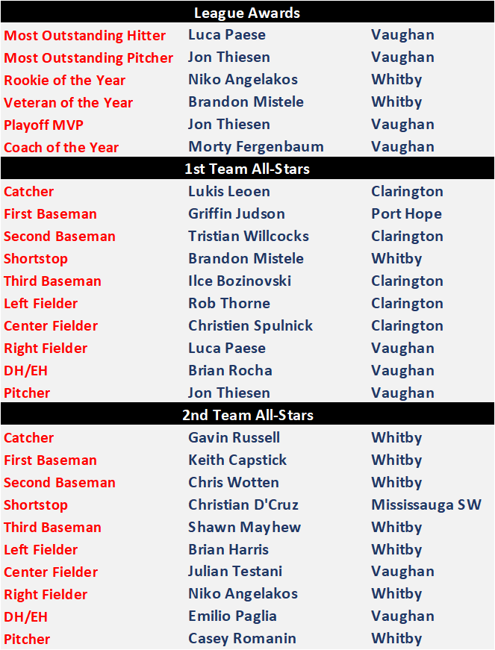
OSBA RESULTS WEEK #13
PORT HOPE FLYERS v. MARKHAM MARINERS
Game 1
Flyers - 3 Mariners - 8
WP - Timothy Mark LP - Brendan Tink
Game 2
Flyers - 1 Mariners - 11
WP - Aidan Pickering LP - Matt Vrooman

WHITBY CANADIANS vs BOWMANVILLE DODGERS
Games postponed due to wet field conditions

CLARINGTON CUBS vs MARTINGROVE SOX
Games postponed due to wet field conditions

CLARINGTON CUBS vs PORT HOPE FLYERS
Cubs - 6 Flyers - 5
WP - Shawn Lamb LP - Mike McNaught SV - Spencer Muirhead
HR - Ilce Bozinovski (Cubs), Kelly Durack (Flyers)

MARTINGROVE SOX vs YORK DIAMONDS
Sox - 1 Diamonds - 4
WP - Eric Foley (CG) LP - Rory Burke (CG)

OSBA RESULTS WEEK #14
WHITBY CANADIANS vs BOWMANVILLE DODGERS
Game 1
Dodgers - 7 Canadians - 4
WP - LP -
Game 2
Dodgers - 0 Canadians - 10
WP - LP -
VAUGHAN VIKINGS vs MISSISSAUGA SW TWINS
Game 1
Vikings- 9 Twins - 10
WP - Tim Westlake LP - Marco Sacilotto
McEnroe walk-off double
Game 2
Vikings - 5 Twins - 1
WP - Marco Sacilotto (CG) LP - Peter Westlake (CG)

YORK DIAMONDS vs MILTON ORIOLES
Game 1 - suspended in the 4th inning
Game 2 - postponed by rain

MARKHAM MARINERS vs CLARINGTON CUBS
Game 1
Mariners - 7 Cubs - 8
WP - Tristan Willcocks LP - Tyler Whiteford
HR - Rob Thorne (Cubs)
Game 2
Mariners - 4 Cubs - 7
WP - Nick Demone LP - David DeCassan SV - Taylor Fitze

PORT HOPE FLYERS vs MARTINGROVE SOX
Flyers - 3 Sox - 0
WP - Bobby Gilligan (CG - 8 K's) LP - Rory Burke (9 K's)

BOWMANVILLE DODGERS vs PORT HOPE FLYERS
Dodgers - 5 Flyers - 4
WP - Curtis March LP - Brady Fowler SV - Anthony Qaqish

VAUGHAN VIKINGS vs YORK DIAMONDS
Vikings - 9 Diamonds - 4

WP - Marco Sacilotto LP - Martin Rodriguez HR - Mike Mastrangelo (Vikings)

MARTINGROVE SOX vs MISSISSAUGA SW TWINS
Game postponed due to lightning

Aces Off To Solid Start At Nationals
The OSBA Aces started the CNOBF Vintage Nationals with a very productive Friday.
The 33+ team won their game 15-7 over the Mississauga Cubs. Julian Testani (Vikings) led the way going 3-3 with an RBI and a stolen base. Justin Rattray (Orioles) went 2-2 with 4 RBI and Eduardo Fajardo (Diamonds) also had two hits, The Aces broke open a 5-5 tie with 6 in the 5th and 4 in the 6th. Marco Sacilotto (Vikings) threw 2 shutout innings to earn the in in relief.
The 43+ team had two games. They won the opener 3-1 over the Dufferin-Simcoe Braves. Jeremy McQuay (Dodgers) singled home John Tokatlidis (Sox) to give the Aces a 1-0 lead in the third inning. McQuay's sacrifice fly again scored Tokatlidis to make it 2-0 in the 5th. In the 7th, Rich Freeman's (Diamonds) third hit of the day plated Syndey SAunders (Diamonds) to mae it 3-0. The Braves got 1 in the 7th but Eric Foley (Diamonds) pitched out of trouble to earn the save. Winning pitcher Mike O'Donnell was outstanding in his 3 shutout innings, as was Bruce Ross (GHBL) in his 2 innings. Several strong defensive plays were turned in including a nifty from 5-3 double play from Manny Rodriguez (Diamonds).
The second game was a see-saw affair with a solid Scarborough Maroons team. The game ended in a 5-5 tie. Pitchers Eric Foley, Bruce Ross, and Syndey Saunders kept the Aces in the game. Rob Rivers (ex-Diamonds) went 2-2 wth a walk and Jeff Bond (Twins) was 2-3. Ben Chisholm (Twins) was outstanding behind the plate in both games.
Both Aces teams are in good position. as we move into Saturday's games.

Aces Move On To Sunday
Both Aces teams are still alive at the CNOBF National Championships.
The 43+ team earned the top seed and a bye to the final vs Dufferin-Simcoe or Scarborough after a 14-4 win over the Hamilton Stealers. OSBA took advantage of 10 walks and 5 hit batsman while making the most of their 5 hits. Jeff Bond (Twins) smashed a 2-run double off the left field wall. The story was pitching for the Aces as Mike O' Donnell (Twins) went three more solid innings. This was followed by 2 excellent frames from Bruce Ross (GHBL) and one inning from Paul Freeman (Diamonds). Ross has now appeared in all 3 games this weekend. Ben Chisholm continued to be outstanding behind the plate.
The 33+ team already knew that all teams would make the semifinals so pitchers were rested for tomorrow. The Aces lost both games (12-6 to Guelph and 11-7 to Tillsonburg). The club is raring to go for their semifnal matchup with the Misssissauga Cubs tomorrow. Mike Shuryn (Orioles) twirled three outstanding innings in the first game. Lee Mathe (Orioles) has had a torrid start to the tournament going 4-5 with 4 walks.

Aces Fall Just Short
The Aces 43+ team was involved in an incredible national championship game against Dufferin-Simcoe. The Braves came out on top 15-13 in the slugfest while outhitting the Aces 21-18.
Dufferin-Simcoe jumped out to a 10-0 lead before the Aces countered with 2 in the second, 6 in the third, and 1 in the 4th to make it 10-9. The big blow was a 3-run inside the park home run from Jeff Bond (Twins). The Braves then went back up 15-9 as the Aces came in for the their last at bats. Never giving up, OSBA scored 4 runs and brought the tying run to the plate but couldn't quite complete the miraculous comeback.
Overall, the team had a fantastic weekend with so many great performances.
Mike O'Donnell (Twins) and Eric Foley (Diamonds) both pitched three times. Burce Ross (GHBL) appeared in all 4 games. Catcher Ben Chisholm (Twins) caught all 27 innings and threw out 2 runners.
At the plate, there were many solid performacnes including:
Rich Freeman (Diamonds) 7-11 with 2 doubles
Jeff Bond (Twins) 6-11 with 2 doubles, a home run, and 7 RBI
Jeremy McQuay (Dodgers) 4-9 with 4 and RBI 5 stolen bases
The 33+ team got off to fast start in their semifinal game with the Mississauga Cubs. Lee Mathe (Orioles) blasted a long home run in the 1st to give the Aces a 2-0 lead. After the Cubs had taken a 5-3 lead, Mike Caicco (Vikings) smacked a solo home run in the 4th to tie things at 5-5. It was all downhill from there as the Cubs' hot bats propelled them to a 15-5 win.
Standouts for the weekend included:
Lee Mathe (Orioles) 7-8 with 1 HR 4 RBI 4 BB, and reached base in his last 11 consecutive plate appearances!!
Justin Rattray (Orioles) 3-7 with 6 RBI
Rob Fougere (Orioles) 3-8 with 4 runs scored
Mike Shuryn (Orioles) 3-9 with 5 runs scored and 3 shutout inning pitched
The Aces are looking forward to next year's championshops to be held in Charlottetown, Prince Edward Island.

2024 OSBA CHAMPIONS - VAUGHAN VIKINGS

