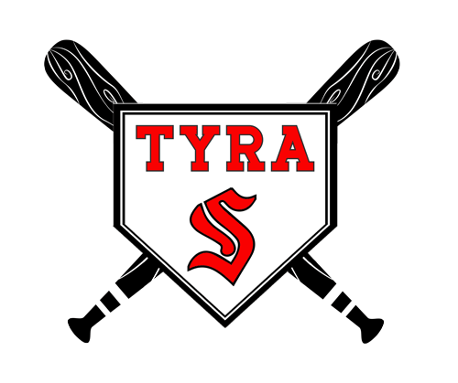
2026 TYRA REGISTRATION
Circle:
T-Ball: t-ball (4-6 yr. old)
Baseball: 7/8 yr. old 9/10 yr. old 11/12 yr. old Age
Eligibility:
T-ball - Players age by January 1, 2026
Baseball – Players age before May 1, 2026
Cost:
T-ball $50 Individual
*Baseball $75

Sex (Circle): Male Female
Player’s Name: ____________________________________________________ Date of Birth: ______________________
Address: ___________________________________________________________________________________________
Primary Contact: _________________________________________________
Home Phone: ______________________________________ Cell Phone: ________________________________ Email: _________________________________________________________
Secondary Contact: _______________________________________________
Home Phone: _____________________________________ Cell Phone: _______________________________ Email: __________________________________________________________
Emergency Contact (if parent/guardian cannot be reached):
Name: _____________________________________________ Phone Number: _________________________________
Player’s Shirt/Hat Size (circle one shirt and one hat)
Youth X-Small Youth Large Adult Small HATS Youth Small Youth X-Large Adult Medium Youth Hat Youth Medium Adult Large Adult Hat
Please print the name you would like on your child’s jersey and the 3 top choices for a number:

Name on Jersey: ____________________________________________ Top 3 Number Choices: ___________________

TBALL ONLY: You can fill out a request of a coach or list another child you would like on your child’s team. (We will try and accommodate each request). ____________________________________________________________________

