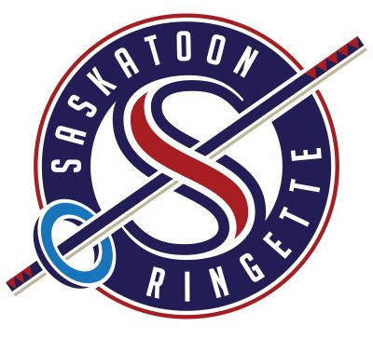
Saskatoon Ringette Association
128 – 510 Cynthia Street
Saskatoon, SK
S7L 7K7
306.975.0839
office@saskatoonringette.com
saskatoonringette.com

SRA PICK-UP CHART FOR 2025-2026

- FUN3 teams can pull-across from other FUN3 teams with permission from the opposing team. This should only be done when absolutely necessary.
- U12 White can draw from Fun3 and U12 White
- U12 Blue can draw from U12 White
- U14B can draw from U14B & U12 Blue & U12 White
- U14A can draw from U14B & U12 Blue
- U14AA can draw from U14A & U14B
- U16B can draw from U16B, U14A & U14B
- U16A can draw from U16B & U14AA & U14A & U14B
- U16AA can draw from U16A, U16B & U14AA
- U19B can draw from U16A & U16B & U19A & 18+ (when playing against 18+)
- U19A can draw from U19B, U16A & U16B & 18+ (when playing against 18+)
- U19AA can draw from U19A, U19B or U16AA & 18+ (when playing against 18+)
- 18+ teams can draw from all U19 and U16 athletes

*Teams must check with Tournament Committees regarding their Tournament pick-up rules before securing players. SRA is not responsible if teams pick-up ineligible players.

